Running the Java Custom Function Example

# Overview

These files can be used to create a WindwardCustomFunctions.jar file containing your own custom functions, to be used with the Windward Java engine, version 11.0.0.0 or newer.

The *CustomFunctionExample.ipr* is a project file for IntelliJ, a Java IDE.

# Important Notes

1. Compile using Java version *1.4* or earlier.
2. Do not change the version of the JAR created using this code.
3. To use, replace the assembly of the same (WindwardCustomFunctions.jar) name where you installed the Java engine.

# Requirements

* Windward Reports Java Engine
  + Available from the [Windward downloads](http://www.windwardreports.com/downloads.htm) page.
* IntelliJ IDEA
  + Available from <http://www.jetbrains.com/idea/download/index.html>Tutorial

## Step 1: Creating Custom Functions

1. Open Catapult. (Found under Start -> All Programs -> Windward Studios -> Windward Reports Java Engine -> Java Engine Help Launcher)
2. In the Catapult menu, click the Custom Function tab.
3. Click the Project file button.

*In the file WindwardCustomFunctions.java, you can write your own custom functions to be used with the Java Engine. We are provided with five functions here, Pi, square root, multiply all, add total and get total. In the following steps, we will add a function E() that returns the value of Euler’s constant, e.*

1. Change the number of functions to 6.
2. Paste the following code in the second section (below multiply all) to add the function’s information:  
   functionName[5] = "E";  
   functionFullName[5] = "E()";  
   functionDescription[5] = "Returns the value of e, 2.71828182845904, accurate to 15 digits.";  
   functionNumberOfArgument[5] = new Integer(0);  
   functionArgumentName[5] = null;  
   functionArgumentDescription[5] = null;  
   functionArgumentType[5] = null;
3. Verify that the indentation is correct; the resulting code should look like this:  
   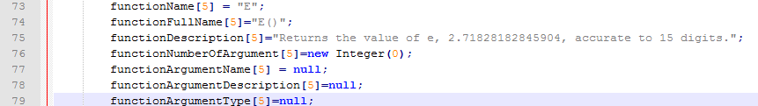
4. Paste the following code in the third section (below get total) to add the function itself:  
   public static Object E() {  
   return new Double(2.71828182845904);  
   }
5. Verify that the indentation is correct; the resulting code should look like this:  
   
6. Click Build, Rebuild Project.

## Step 2: Installing WindwardCustomFunctions.jar for use with the Java Engine

1. In Catapult’s Custom Function tab, click the source button.
2. In the source folder, go to out, artifacts, WindwardCustomFunctions.
3. Copy the file WindwardCustomFunctions.jar
4. Navigate to the install directory of the Java Engine.
5. Open the folder jar.
6. Delete the current WindwardCustomFunctions.jar file.
7. Paste your new file in its place.